BlueWeb Runbook
Post-Maintenance Failures: LDAP Sync Job and LMS Portlet
Liferay DXP 7.4 • PROD • August 2026

Environment
Application | BlueWeb portal, Liferay DXP 7.4
PROD nodes | 11LV and 12LV (clustered)
App server | Apache Tomcat 9.0.121
Dispatch jobs | LDAP Sync — every 5 min (0 0/5 * * * ?) All: America/Chicago, All Nodes, Overlap Allowed unchecked

Two different failures
Part A | LDAP Sync job stops running after a Tomcat upgrade. Fixed by deleting an orphaned job log record. A restart does NOT fix it.
Part B | LMS Portlet shows "temporarily unavailable" after Java patching. Fixed by restarting the affected node.
Check the symptom and pick the right part. The fixes are not interchangeable.

Part A — LDAP Sync Job Stops Running (Tomcat Upgrade)
Symptom | LDAP Sync shows Canceled at 0 ms on every 5-minute fire. No group changes reach BlueWeb.
Error text | Only one instance in progress is allowed
Occurred | 2026-08-27, during the Tomcat 9.0.120 → 9.0.121 binary upgrade
Impact | Group sync dead 19:15 CDT → 00:50 CDT (~5.5 hours)
Fix | Delete the orphaned DispatchLog row from the script console
Trigger ID | 219121732 (PROD — verify in your environment)

A1. The issue
Tomcat was stopped for the upgrade while an LDAP Sync run was in flight. The run had already inserted its DispatchLog row with a start time, but the JVM died before the code that writes the end date and completion status could execute. That row was left permanently open.
The trigger has Overlap Allowed unchecked. Before each fire, Liferay queries DispatchLog for a row with a start time and no end date — if it finds one, it assumes a run is still going and skips the fire. The log table is the lock; there is no separate in-memory flag. So the orphaned row blocked every trigger from that point on, and the job could not recover on its own.
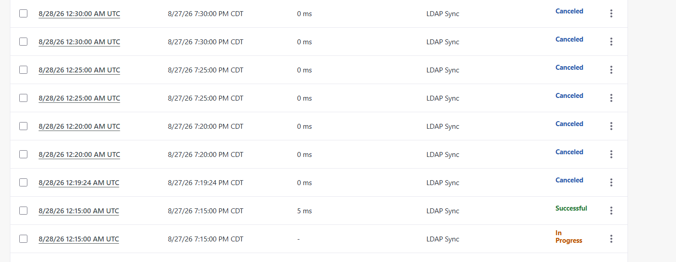
Figure 1 — Every trigger Canceled at 0 ms, with one In Progress entry that never completes.
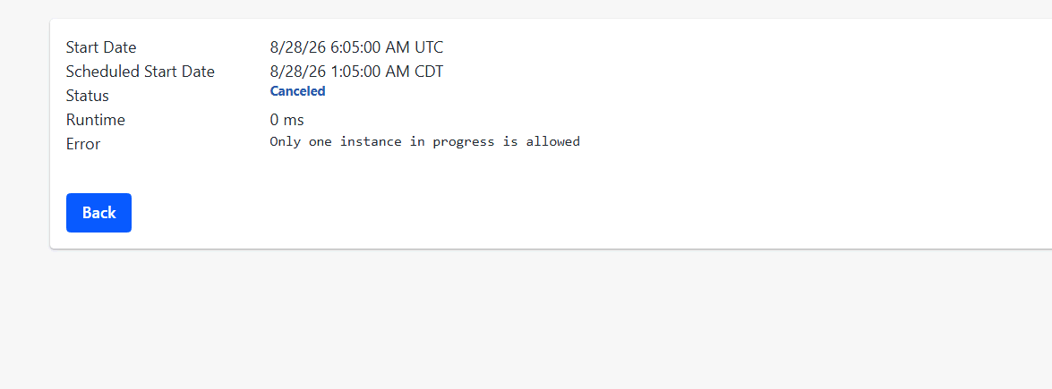
Figure 2 — Detail view of a cancelled entry — this error text is the signature of the failure.
One Successful plus one Canceled per 5-minute slot is normal on a two-node cluster: one node works, the other backs off. The fault is when there is no Successful row in any slot.

A2. Finding the orphaned row
Run in the script console (Groovy). An open row is one with no end date — in a healthy system this returns nothing.
import com.liferay.dispatch.service.*

long triggerId = 219121732L

def logs = DispatchLogLocalServiceUtil.getDispatchLogs(triggerId, 0, 300)
out.println("rows examined: " + logs.size())

logs.findAll { it.getEndDate() == null }.each {
out.println("OPEN: logId=" + it.getDispatchLogId()
+ " start=" + it.getStartDate()
+ " status=" + it.getStatus())
}
Expected output when a row is stuck — the start time will match the shutdown or interruption:
rows examined: 300
OPEN: logId=219613339 start=Thu Aug 27 19:15:00 CDT 2026 status=1
On a healthy system only the row count prints and no OPEN lines appear.
If the trigger ID is not known:
import com.liferay.dispatch.service.*

DispatchTriggerLocalServiceUtil.getDispatchTriggers(-1,-1).findAll {
it.getName().toLowerCase().contains("ldap")
}.each { t ->
out.println(t.getName() + " triggerId=" + t.getDispatchTriggerId()
+ " active=" + t.isActive() + " cron=" + t.getCronExpression())
}

A3. The fix
The Job Scheduler UI offers Delete only on completed rows — an IN_PROGRESS row has no Delete option, so it must be removed from the script console.
import com.liferay.dispatch.service.*

long logId = 219613339L // <-- from A2

def l = DispatchLogLocalServiceUtil.getDispatchLog(logId)
out.println("deleting: start=${l.getStartDate()}"
+ " end=${l.getEndDate()} status=${l.getStatus()}")

DispatchLogLocalServiceUtil.deleteDispatchLog(l)
out.println("deleted")
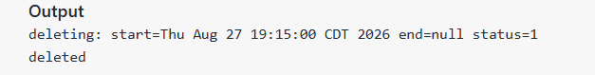
Figure 3 — Successful deletion. Re-running the script afterwards throws "No DispatchLog exists with the primary key", confirming the row is gone.
Confirm nothing else is open:
import com.liferay.dispatch.service.*

def logs = DispatchLogLocalServiceUtil.getDispatchLogs(219121732L, 0, 300)
out.println("rows examined: " + logs.size())
out.println("open rows: " + logs.count { it.getEndDate() == null })
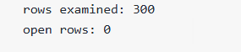
Figure 4 — open rows: 0 is the target state.

Wait for the next 5-minute boundary and verify runs are completing:
import com.liferay.dispatch.service.*

DispatchLogLocalServiceUtil.getDispatchLogs(219121732L, 0, 12).each {
out.println("${it.getStartDate()}"
+ " runtime=${it.getEndDate().getTime() - it.getStartDate().getTime()}ms"
+ " status=${it.getStatus()}")
}
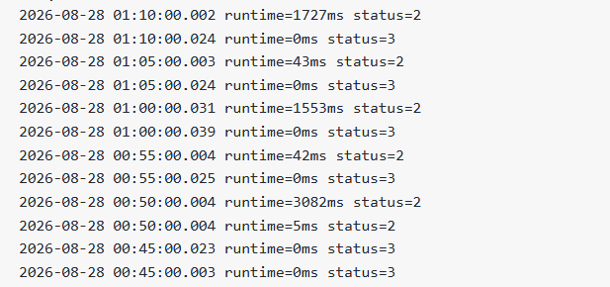
Figure 5 — Healthy output. Each slot has one working run (status=2) and one node backing off (status=3). The 00:45 pair with two status=3 rows is the last of the blocked fires before the fix.

A4. Emergency workaround
If the row cannot be deleted immediately, checking Overlap Allowed on the trigger restores the sync straight away — it makes Liferay skip the in-progress check entirely.
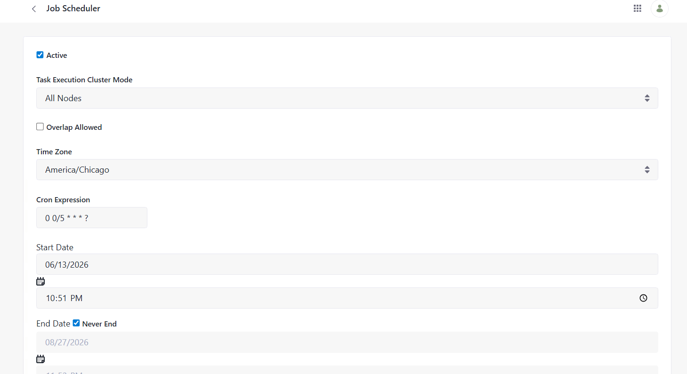
Figure 6 — Job Scheduler configuration. Toggle only Overlap Allowed; leave every other setting untouched.
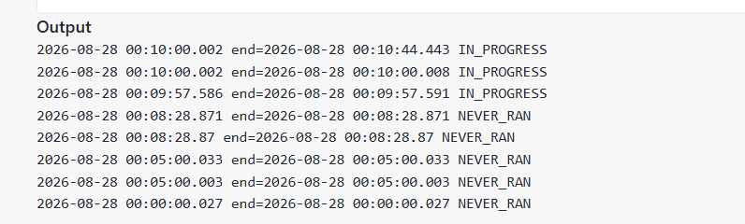
Figure 7 — With Overlap Allowed checked, the cron fires complete again. The 44-second run is the backlog being processed.
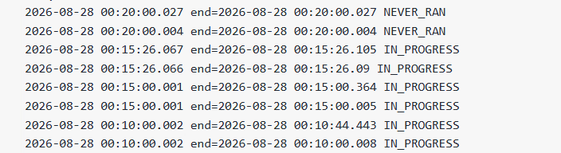
Figure 8 — Unchecking Overlap Allowed before deleting the orphaned row brings the block straight back — proof that the log row, not scheduler state, is the cause.
Temporary only. With overlap protection off, a future hang would let instances stack every 5 minutes, all writing group membership to the same users concurrently. Re-enable it once the row is deleted.

A5. Watch out for
- A restart does not fix this. DispatchLog is a database table and survives a restart — and the restart itself can orphan a second run.
- A Tomcat rollback does not fix this either. The blocking record is a database row; reverting binaries does not touch it, and the rollback requires another shutdown.
- Toggling the trigger Active off and on does not fix this. It re-registers the job, but the same open row is still found on the next fire.
- Do not map status codes with DispatchTaskStatus.values()[status]. The numeric codes do not follow enum ordinal order — status=2 renders as Successful and status=3 as Canceled. Judge rows by whether endDate is null.
- Before any planned Tomcat restart: uncheck Active on LDAP Sync, confirm open rows = 0, do the work, then re-check Active. This prevents the orphaned row entirely.
- NAVEX SFTP and LMS LISTS share the same All Nodes / Overlap Allowed unchecked configuration and can fail the same way — far less likely, since they run daily rather than every 5 minutes.
Check every trigger at once:
import com.liferay.dispatch.service.*

DispatchTriggerLocalServiceUtil.getDispatchTriggers(-1,-1).each { t ->
def open = DispatchLogLocalServiceUtil
.getDispatchLogs(t.getDispatchTriggerId(), 0, 50)
.count { it.getEndDate() == null }
if (open > 0) out.println("STUCK: ${t.getName()}"
+ " triggerId=${t.getDispatchTriggerId()} open=${open}")
}
Silent output means everything is clean.
- After an outage longer than an hour: the sync resumes from the directory's lastChangeNumber, so the gap only replays if the changelog still holds those entries. Ask the directory team for firstChangeNumber on cn=changelog and compare. If it trimmed past that point, changes from the window are lost and will surface later as individual access tickets.

Part B — LMS Portlet Temporarily Unavailable (Java Patching)
Symptom | LMS page renders but the portlet area shows: LMSPortlet is temporarily unavailable.
Underlying error | NullPointerException — Cannot invoke com.bcbsa.lms.model.Contact.getPlanName() because "lmsUser" is null
Occurred | 2026-08-22, found during post-patch testing after Java patching on PROD
Fix | Restart the affected node. Check 11LV first, then 12LV.

B1. The issue
Users opening the List Management System (LMS) page see the site chrome and navigation render normally, but the portlet is replaced by a red banner. Liferay shows this message whenever a portlet throws an unhandled exception during render — the banner itself gives no cause, so the server log is required.
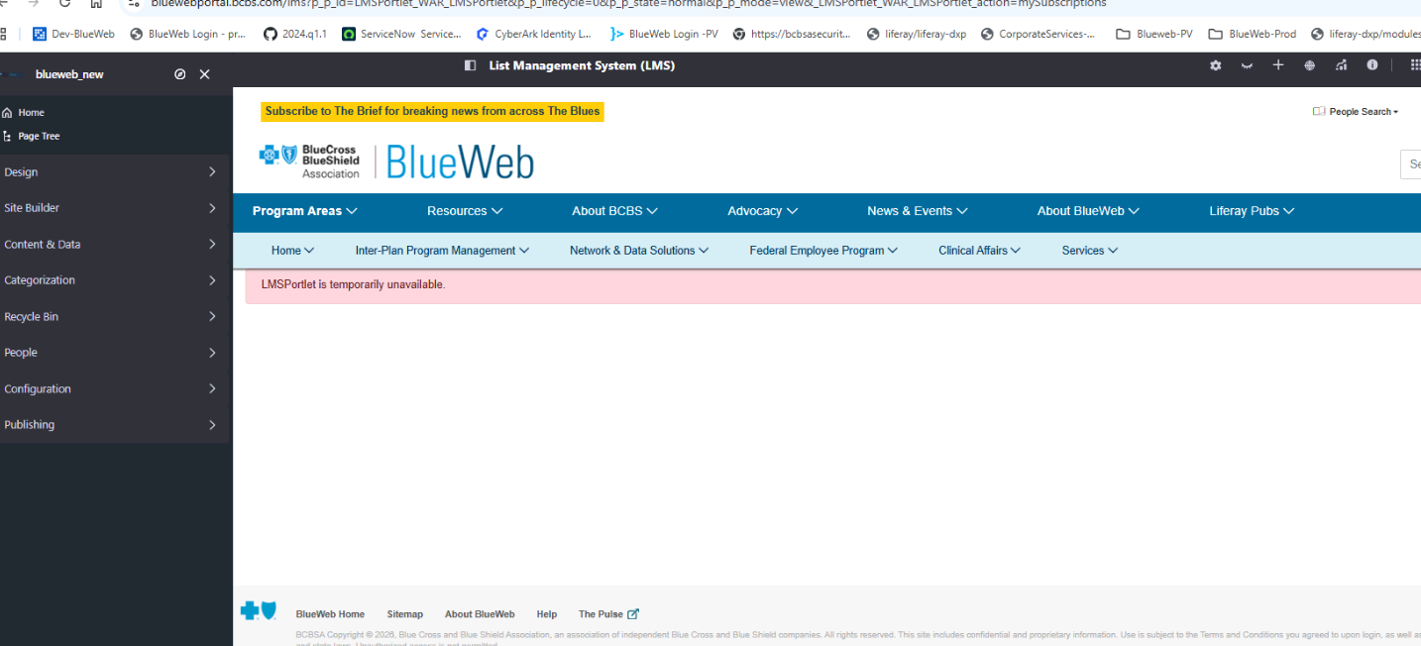
Figure 9 — The LMS page as the user sees it. Page frame and navigation are fine; only the portlet has failed.
In catalina.out the failure appears as a PortletException wrapping a NullPointerException. The outer exception is generic Liferay portlet plumbing — the useful information is in the Caused by block near the end.
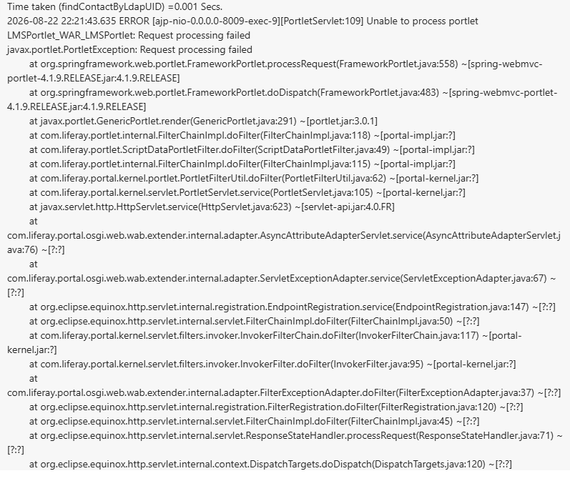
Figure 10 — Start of the error. Note the first line: findContactByLdapUID completed in 0.001 seconds — far too fast for a real directory lookup, meaning it returned null without doing useful work.
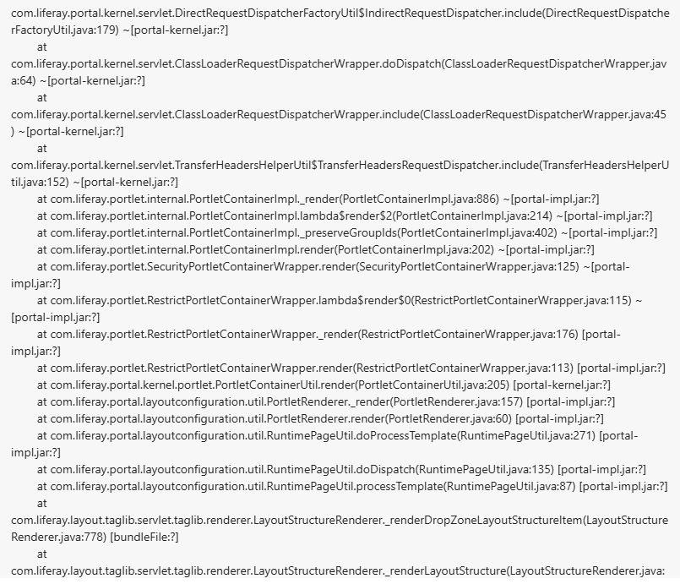
Figure 11 — Continuation of the render stack through PortletContainerImpl and LayoutStructureRenderer. Generic plumbing, not the cause.

The actual cause is at the bottom of the trace:
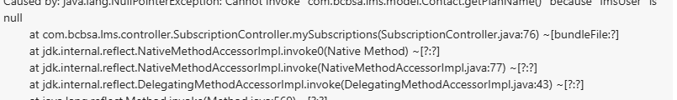
Figure 12 — SubscriptionController.mySubscriptions() line 76 dereferences lmsUser, which is null because the LDAP contact lookup returned nothing.
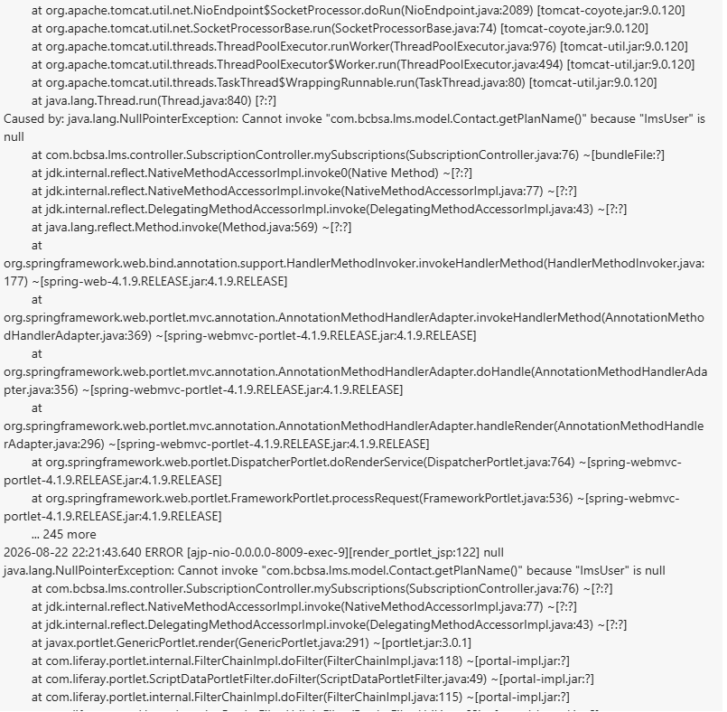
Figure 13 — Full Caused by section in context, showing the NullPointerException propagating out through the Spring portlet handler.
The sequence: the controller calls findContactByLdapUID to resolve the logged-in user against the directory; the call returns in 0.001 seconds with null; the controller then calls getPlanName() on that null object and throws. Because this happens during render, Liferay swallows the exception and shows the "temporarily unavailable" banner.
The lookup began failing after Java patching while the JVM was otherwise running normally — consistent with a stale directory connection or connection pool held across the patch. A restart rebuilds those connections and the portlet renders again.

B2. The fix
PROD runs on two nodes. The failure may affect one or both, so check in order rather than restarting blindly.
- Open the LMS page and reproduce the error.
- Check catalina.out on 11LV for the NullPointerException on Contact.getPlanName().
- If the error is present on 11LV, restart that node.
- Re-test the LMS page.
- If the error persists, check catalina.out on 12LV for the same trace.
- If present, restart 12LV and re-test.
Log search to confirm the right failure:
grep -n "LMSPortlet_WAR_LMSPortlet" catalina.out | tail -20
grep -n "Contact.getPlanName" catalina.out | tail -20
grep -n "findContactByLdapUID" catalina.out | tail -20
A findContactByLdapUID line reporting a near-zero elapsed time immediately before the exception confirms the lookup is returning null rather than failing outright.

B3. Watch out for
- A restart IS the correct action here, unlike Part A. The state that needs clearing lives in the JVM, not the database.
- Check both nodes. A user hitting the healthy node will see the page working, which can make the issue look resolved when it is not.

